ExperimentNo:09
Date: _______
Experiment Title: Data Flow Diagram for Student Management System

Aim:
To design a Data Flow Diagram (DFD) for a Student Management System to represent the flow of data between external entities and the system.

Problem Description:
The Student Management System is developed to efficiently handle and manage all student-related activities in an institution. It maintains records such as student personal details, course registration, attendance tracking, examination data, and results.
The system interacts with multiple entities:
- Student → provides personal and academic data
- Course → provides course details
- Exam → provides exam-related information
- Attendance → provides attendance records
The system processes all these inputs and generates meaningful outputs such as:
- Personal Information Display
- Registered Course Details
- Exam Results

Given Conditions / Constraints:
- The system must include Student, Course, Exam, and Attendance
- All data interactions must be clearly represented
- Only essential processes should be included (Level 0 DFD)
- Data flow should be properly labeled
- Diagram should be simple and easy to understand

Approach / Methodology:
The DFD was designed using a structured approach. First, external entities such as Student, Course, Exam, and Attendance were identified. Then, the main process “Student Management System” was placed at the center. Data flows such as student data, course data, exam data, and attendance data were identified and connected. Outputs such as personal information, registered courses, and results were also represented.

Planning and Estimation:
The system was designed as a Level 0 DFD with a single main process to maintain simplicity. Data flows were limited to essential interactions:
- Student → Student Data
- Course → Course Data
- Exam → Exam Data
- Attendance → Attendance Data
- Outputs → Personal Info, Courses Report, Result
This ensures clarity and avoids unnecessary complexity..

Scheduling / Design Considerations:
The diagram was created by placing the Student Management System at the center, with all entities arranged around it. Arrows indicate the direction of data flow. Proper labeling and spacing were maintained to improve readability.
Diagram:
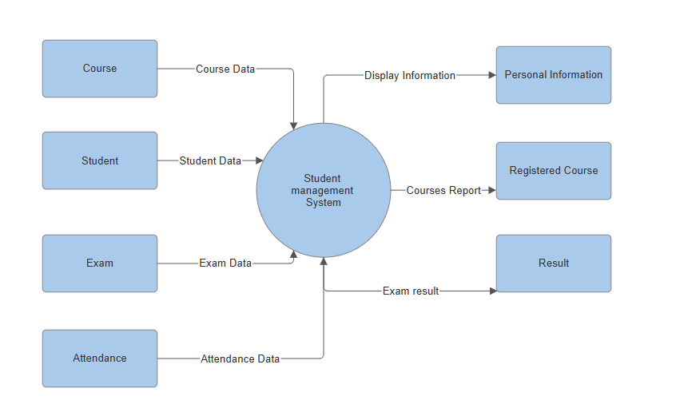

Feasibility Analysis:
- Technical Feasibility: Uses standard DFD concepts and easy to design
- Economic Feasibility: No cost involved (conceptual model)
- Operational Feasibility: Reflects real-world student management processes
- Schedule Feasibility: Can be completed within given time

Result:
A Data Flow Diagram for the Student Management System was successfully designed showing all inputs and outputs.

Conclusion:
The DFD helps in understanding the structure and working of the Student Management System by visually representing data movement.

